Macroeconomic Structural Shifts in Nepal

1. Data Collection and Preprocessing
For this analysis, I utilized the World Bank’s comprehensive macroeconomic dataset. To perform a focused and cohesive analysis, I filtered the 3,361 available indicators down to five core pillars of Nepal's economy: Annual GDP Growth, Inflation, Agriculture (% of GDP), Exports (% of GDP), and Imports (% of GDP).
During the initial data cleaning phase, I identified and removed duplicated rows. Because historical data from the 1960s and 1970s contained missing values (NaN) after pivoting the dataset, I applied linear interpolation combined with forward and backward filling (ffill, bfill). This ensured chronological continuity and prevented gaps in the time-series visualizations.

2. Feature Engineering
To extract deeper economic insights beyond the raw metrics, two new features were engineered:
- Net Exports (% of GDP): Calculated by subtracting Imports from Exports, this feature acts as a direct measurement of Nepal's ongoing trade deficit.
- 5-Year Moving Average (GDP Growth): Because developing economies often experience extreme annual volatility due to natural disasters or global shocks, a rolling 5-year average was calculated to smooth out the noise and reveal the true, long-term trajectory of economic growth.

3. Exploratory Data Analysis & Visualizations
A. Indicator Correlation
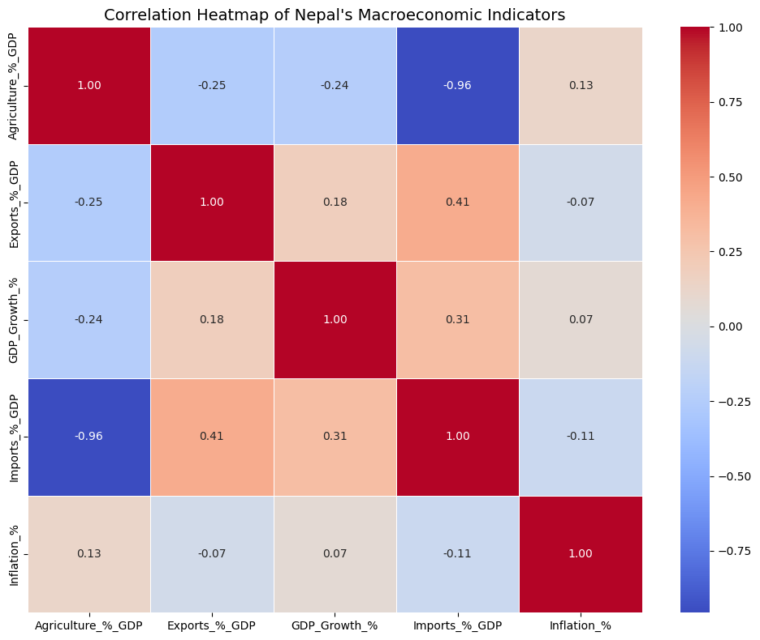
The correlation heatmap reveals several critical relationships. Most notably, there is a severe inverse correlation between Agriculture and Imports. As Nepal's import dependency has grown over the decades, the agricultural sector's contribution to the economy has heavily declined. Additionally, there is a positive correlation between Exports and Imports, indicating that while they grow together, Nepal's import volumes vastly outpace its export capacity.
B. Long-Term Economic Growth
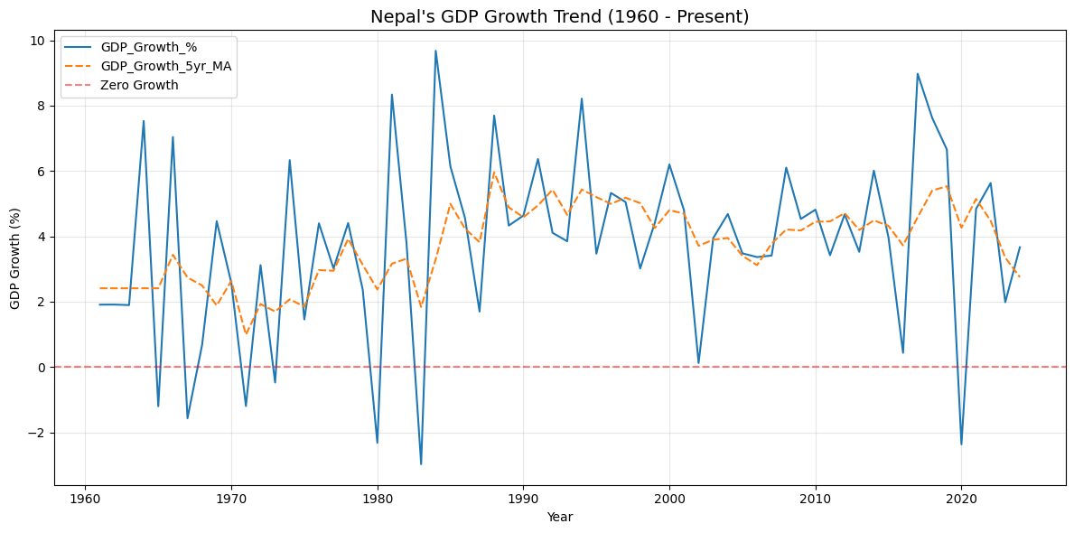
The GDP trend visualization demonstrates extreme vulnerability to short-term shocks, visible in the highly volatile annual growth line. However, the engineered 5-year moving average proves that Nepal's baseline economic growth stabilizes historically between 2% and 6%. The inclusion of a zero-growth reference line clearly highlights severe recessionary periods where the economy actively shrank.
C. The Structural Shift
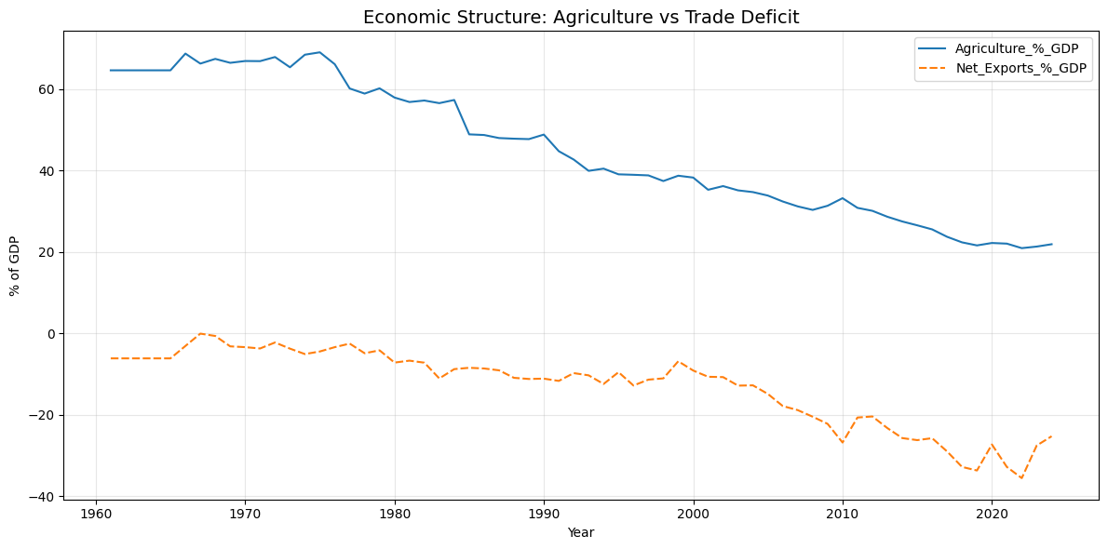
This visualization captures the fundamental structural shift in Nepal's economy. The transition is clear: there has been a steady, multi-decade decline in the agricultural sector's dominance. Alarmingly, this decline is mirrored almost exactly by a deepening trade deficit (negative net exports), showing that lost agricultural production was replaced by foreign imports rather than domestic manufacturing.

4. Advanced Machine Learning Preparation
To ensure the dataset was fully optimized for future predictive modeling (Machine Learning), advanced preprocessing techniques were applied to the cleaned data. First, a binary target variable (Target_Is_Recession) was created to classify years with negative GDP growth. All continuous features were then standardized using Z-score scaling (StandardScaler) to prevent magnitude bias in future algorithms. Furthermore, because economic recessions are rare events, the dataset suffered from severe target imbalance. The Synthetic Minority Over-sampling Technique (SMOTE) was applied to synthesize realistic recessionary data points, perfectly balancing the dataset before exporting it as nepal_macro_ml_ready.csv.

5. Final Conclusions
The data clearly proves that Nepal has transitioned away from a self-sustaining agricultural economy over the last 60 years. However, because its export manufacturing sector did not grow to replace agriculture, the country now relies heavily on imports to sustain its population. This has resulted in a permanent and widening trade deficit. Any future macroeconomic policy must focus on boosting export capacity to close this critical gap.

